**Sprint 3 - Accuracy Design Document**

**April 20, 2021**

Armand Valentino, Kristina Good

**Table of Contents**

**1.** **EXECUTIVE SUMMARY**

1.1 Project Overview

1.2 Purpose and Scope of this Specification

**2.** **PRODUCT/SERVICE DESCRIPTION**

2.1 Product Context

2.2 User Characteristics

2.3 Assumptions

2.4 Constraints

2.5 Dependencies

**3.** **REQUIREMENTS**

3.1 Functional Requirements

3.2 Security

*3.2.1* *Protection*

*3.2.2* *Authorization and Authentication*

3.3 Portability

**4.** **REQUIREMENTS CONFIRMATION/STAKEHOLDER SIGN-OFF**

**5.** **SYSTEM DESIGN**

5.1 Algorithm

5.2 System Flow

5.3 Software

5.4 Hardware

5.5 Test Plan

5.6 Task List/Gantt Chart

5.7 Staffing Plan

# 

# 

# 1. Executive Summary

## ***1.1*** ***Project Overview***

The goal of this project was to create a program that would make a Sphero SPRK robot complete 5 laps around a figure 8 course.

## ***1.2*** ***Purpose and Scope of this Specification***

This project is to show that our team can create a program that shows how steady this robot can follow a course. This is the last part (3) of the final project. It also shows how we can work as a team.

# 2. Product/Service Description

Many general factors and considerations must be taken into account when talking about this program. Steps will be taken to ensure a smooth operation.

## ***2.1*** ***Product Context***

This product runs independently with a user, and works in unison with the EDU programs on the computer.

## ***2.2*** ***User Characteristics***

Anyone can use this software and product, including younger people. For the most part they are also used for/by:

· Student/faculty/staff/other

· Experience

· Technical Expertise

## ***2.3*** ***Assumptions***

Here describes any constraints or dependencies this design may need or encounter.

## ***2.4*** ***Constraints***

Some factors may limit the program from running properly with the product

· Battery life/limits

· Space, especially for courses

· Access, management and security

· Up-to-date software

· Any unexpected glitch

## 

## ***2.5*** ***Dependencies***

Dependencies examples that will most definitely affect the program:

· This program must need a secure Bluetooth connection between computer and product (Sphero)

· Program needs a computer to execute the commands

# 3. Requirements

Many of the requirements listed within this section have been set in place from the computer science department here at Monmouth. These will be crucial in deciding whether our team successfully completed portions of this project.

## ***3.1*** ***Functional Requirements***

The following table represents the requirements laid out for Sprint 2 Accuracy:

|  |  |  |  |  |  |
| --- | --- | --- | --- | --- | --- |
| **Req#** | **Requirement** | **Comments** | **Priority** | **Date Rvwd** | **SME Reviewed / Approved** |
| Agility_01 | Avoid 3 bottle objects by turning around them |  | Important | April 20th | Completed |
| Agility_02 | Roll over the binder ramp successfully |  | Important | April 20th | Completed |
| Agility_03 | Knock down the dry-marker pins |  | Important | April 20th | Completed |

## ***3.2*** ***Security***

### 

### **3.2.1** **Protection**

Certain factors must be ensured before the robot performs its activities. For example:

- Flat surface (excluding ramp)

- Binder ramp placed

- Pins set up

- 3 Bottle obstacles placed

### **3.2.2** **Authorization and Authentication**

Our team and progress will be overlooked by Professor Gil Eckert

## ***3.3*** ***Portability***

The Sphero company offers many products, including the SPRK. Our program can run on any SPRK device. Furthermore,

- Sphero SPRK can be operated anywhere, so long as the Sphero EDU program is running on a computer or laptop capable

# 4. Requirements Confirmation/Stakeholder sign-off

|  |  |  |
| --- | --- | --- |
| **Meeting Date** | **Attendees** | **Comments** |
| 4-20 | Armand Valentno, Krstina Good | n/a |

# 5. System Design

## ***5.1*** ***Algorithm***

The algorithm for Sprint 3 must be followed similar to the following:

* Start program
* Set roll to 0 degrees at x speed for x seconds
  + Spin 90 degrees for x seconds
* Set roll 90 degrees at x speed for x seconds
  + Spin 0 degrees for x seconds
* Set roll 0 degrees at x speed for x seconds
  + Spin 90 degrees for 2 seconds
* Set roll 90 degrees at x speed for x seconds
* Set roll 90 degrees at x speed for x seconds
* Set roll 225 degrees at x speed for x seconds
* END

## ***5.2*** ***System Flow***

## Below is the system flow chart mapping out what our block code for Sprint 2 should look like:

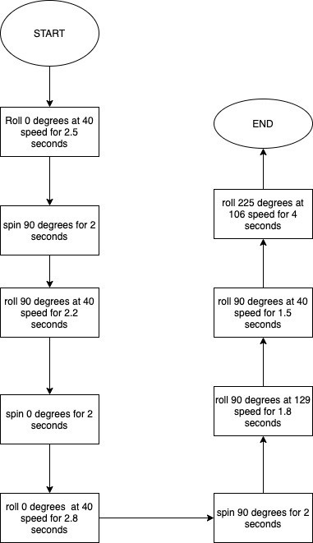

● The actual block coding program that was created and used on the robot is below, along with the sensor data showing zigzags avoiding obstacles, ramp jump, and pin knockdown: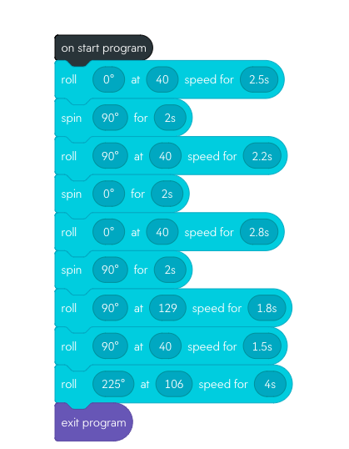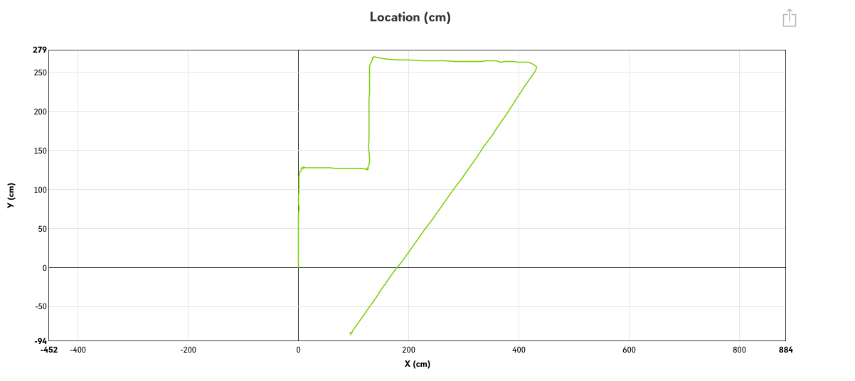

***5.3*** ***Software***

The software used to create and run this program is called Sphero EDU. Within the application, block coding is an option to create programs for the Sphero SPRK robot, which is what our team used.

## ***5.4*** ***Hardware***

Our team used a MacBook to test our product and its coding design.

## ***5.5*** ***Test Plan***

|  |  |  |  |  |  |
| --- | --- | --- | --- | --- | --- |
| **Reason for Test Case** | **Test Date** | **Expected Output** | **Observed Output** | **Staff Name** | **Pass/Fail** |
| Roll Individual straights and turns | 4/20 | Slowly approach each corner, stop, turn then continue | Robot took its time when we put the “rotate” blocks | Kristina, Armand | Pass |
| Speed and seconds to jump the ramp | 4/20 | Attempt a jump on the ramp | Robot was too slow, could not go up ramp | Kristina, Armand | Fail |
| Increase speed, lowered the seconds | 4/20 | Jump the ramp and continue to last corner | Successful ramp jump, slowly rolled to corner to turn. | Kristina, Armand | True |
| Last straight to pins | 4/20 | Turn and speed through the marker pins | Did exactly what was expected | Kristina, Armand | Pass |

## 

## 

## 

## 

## 

## 

## 

## ***5.6*** ***Task List/Gantt Chart***

The Gantt Chart below represents how and what we have planned/completed in Sprint 3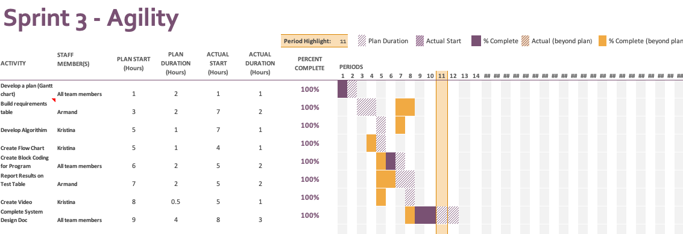

## ***5.7*** ***Staffing Plan***

Below lists a table of contributors to the project, and what roles and responsibility

|  |  |  |  |
| --- | --- | --- | --- |
| Name | Role | Responsibility | Reports To |
| Kristina Good | Coder/contributor | Gantt Chart, Develop algorithm,create flowchart, videographer, completing system design | Professor Gil Eckert |
| Armand Valentino | Coder/coder contributor | Gantt Chart, Create code, completing system design | Professor Gil Eckert |